**Experiment 1:-**

Design a LED flasher.

**Circuit Diagram:-**

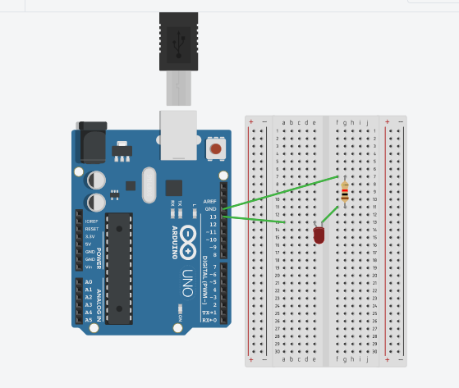

**Theory:-**

**Concepts used in this experiment:-**

The concepts used in performing this experiment-

* The arduino board can supply a power of 5V as digital output signals through 14 pins.
* The GND pin of the arduino board acts as ground.
* In the bread boardthe two rows present at the top and bottom, are connected with each other in series and the columns present in between are connected in a set of 5 each. The connection pattern is shown below: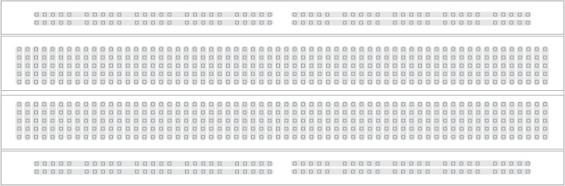

**Learnings and Observation:-**

* **Learnings:**
* I have learned how to work practically with a breadboard and other things.
* I have learned how to combine hardware and software to do miracles.

**Observations:-**

* When we upload the code the Arduino resets and it performs the assigned job that is to flash the led on and off.

**Problems and Troubleshooting:-**

The problems faced by me while doing this task are :-

* The LED which I used was not in a proper working condition.
* The circuit was not working because the wires were not connected properly.
* The port selection is the error which occurs most of the time and can be rectified by selecting Arduino as the port for uploading.

**Precautions:-**

The precautions that should be taken while doing this experiment are:-

* The connections should not be loose.
* Every component should be joined at their appropriate place and it should be properly closed.
* The pinning on the device should match to the pins activated.

**Learning Outcomes:-**

* I have learned to make circuits using Arduino .
* I have understood about input and output channel of circuits.